Electron Video Converter

GitHub Repository: <https://github.com/Ashot72/electron-video-converter>

Application Description Page: <https://ashot72.github.io/electron-video-converter/description.htm>

What is Electron?

Electron is a framework for creating native applications with web technologies like JavaScript, HTML and CSS.

With Electron you build cross platform desktop apps running under Windows, OS X and Linux.

I built video converter application. Users can convert videos from one type to another by means of Electron.

If you are interested only in uploading and downloading video files and video conversions is not your main target then you can run the app as both web and native phone

applications. You can switch to Electron later if you are about to convert some videos. I will show how to run and use the app both on Windows and macOS. My main OS

is Windows 10. OS-X Yosemite 10.10.5 is running via VMware on my Windows 10.

First thing that we should care about is to install actual video conversion application. We are going to use FFmpeg framework [https://ffmpeg.org](https://ffmpeg.org/).

FFmpeg is the leading multimedia framework, able to decode, encode, transcode, mux, demux, filter and play pretty much anything that humans and machines have created it.

FFmpeg works behind the scenes on lot of different many popular video editor software. It is quite well developed.

Let's try to install ffmpeg on macOS. First, we should check if Homebrew is installed on your appearing system. Homebrew is a free and open-source software package management

system that simplifies the installation of software on Apple's macOS operating system.

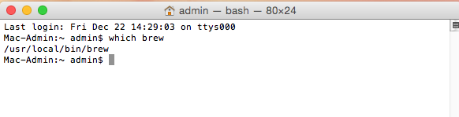

Figure 1

Run 'which brew' command. If you see a line like '/usr/local/bin/brew' then it is installed.

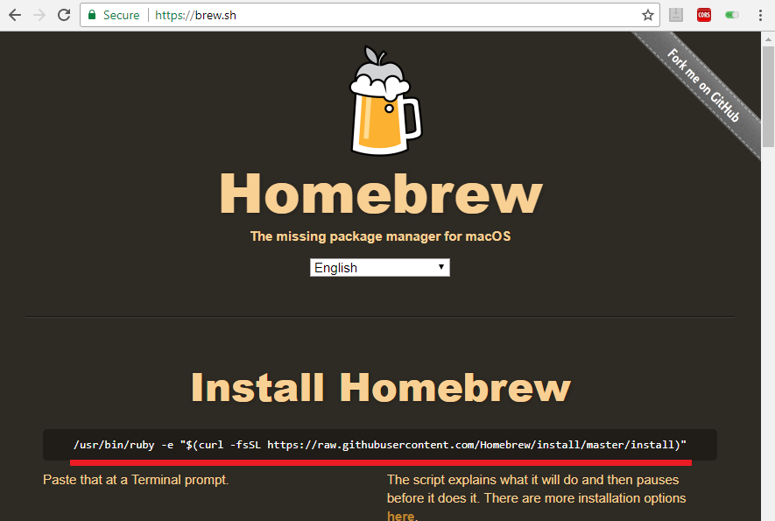

Figure 2

If it is not installed then go to <https://brew.sh/>. Copy the path.

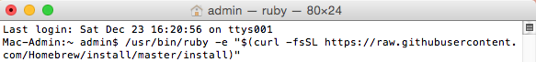

Figure 3

Paste and run it.

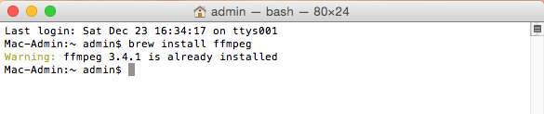

Figure 4

Now it is time to install ffmepg. Run command 'brew install ffmpeg'. In my case it is already installed.

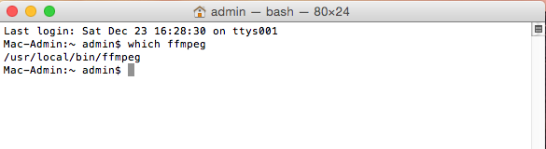

Figure 5

You just run 'which ffmpeg' to find out if ffmpeg has been already installed on the OS or not.

For Windows go to <https://www.wikihow.com/Install-FFmpeg-on-Windows>. Download and install ffmpeg.

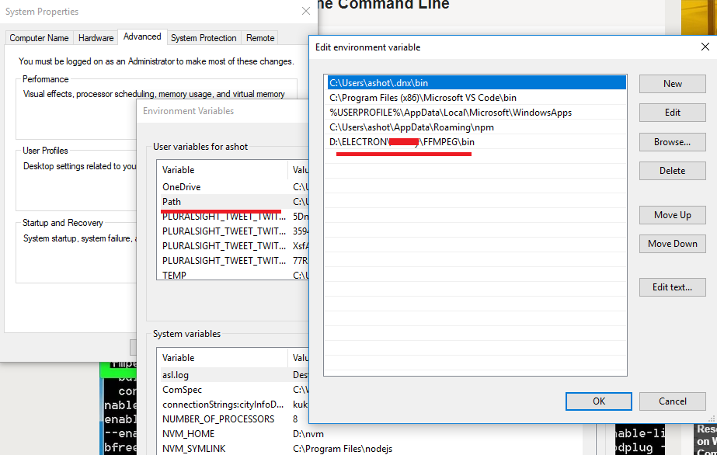

Figure 6

Make sure you added ffmpeg bin folder to Environment Variables Path.

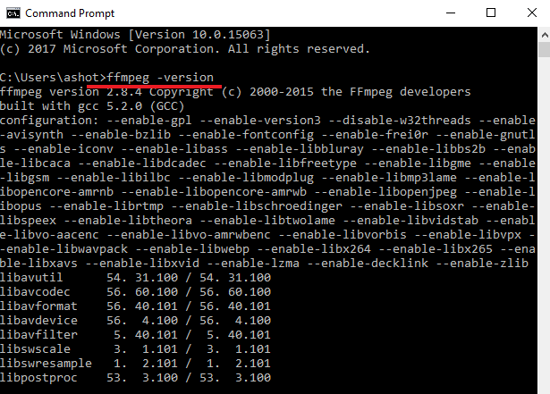

Figure 7

Run 'ffmpeg -version' CMD command to make sure ffmpeg is in Environment Variables Path.

As already stated we can run the app as a native phone or web app just for uploading/downloading video files (no video conversion).

I installed the app on my Galaxy 4 device. First, I ran 'ionic cordova platform add android' to tell ionic that we want to enable Android platform.

Then I connected my phone to my laptop via USB cable then ran 'ionic cordova build android --prod' command to install production version on my phone.

'Electron Video Converter' GitHub does not include Android platform folder (git ignored) so you have to do it yourself if want to have the app installed on your phone.

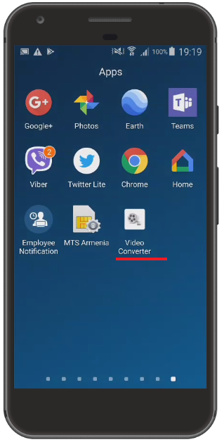

Figure 8

Video converter app installed on my phone.

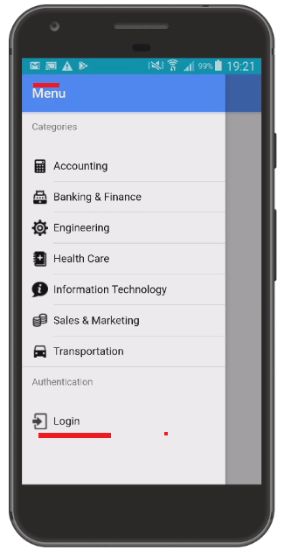

Figure 9

Touch 'Login'.

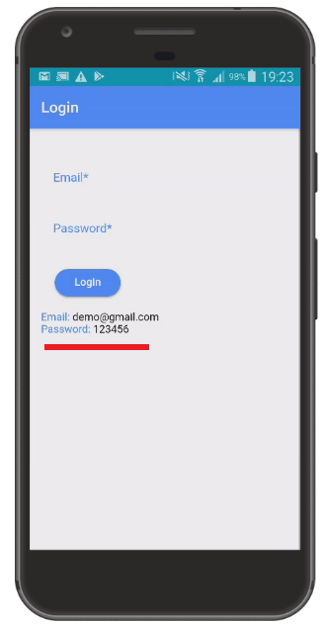

Figure 10

Email is 'demo@gmail.com' and Password '123456' to login. Just assume this is a company user/pass and members of that company can upload video

files with different video types. They just need one user/pass for the app.

I have taken this app shell from my previous 'employee-notification-PWA' GitHub Repository. The categories you see (Figure 5) are not important for this electron video convert app.

We just need some category names and I decided not to change the category names for this app. They are just category names.

This application is hosted publicly. You can go either <http://goo.gl/t7WkD1> or [https://electronvideoconverter.firebaseapp.com](https://electronvideoconverter.firebaseapp.com/) to access the site.

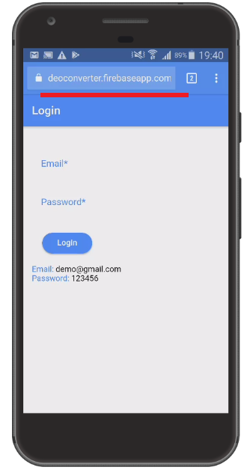

Figure 11

You can run the app as a web app on your phone.

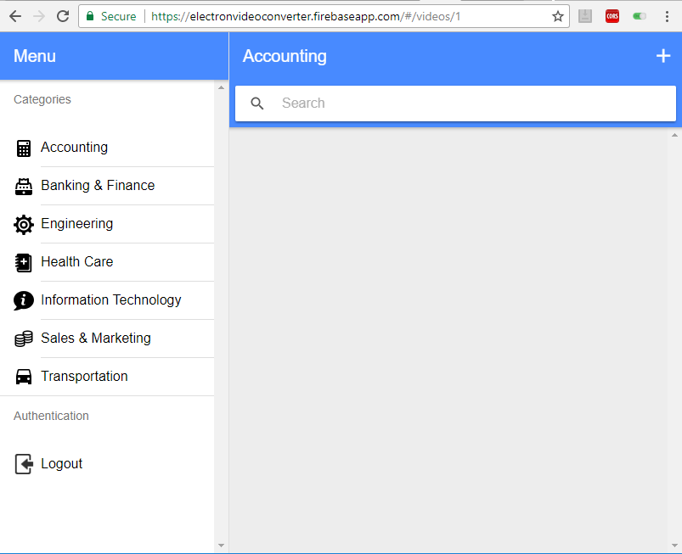

Figure 12

Running via desktop browser app.

It is time to upload some videos.

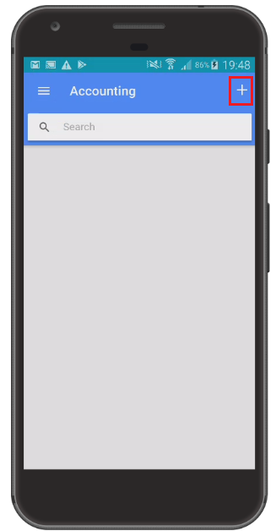

Figure 13

Let's do it via native phone app. After the successful login you will see plus sign at the top right corner. Touch it.

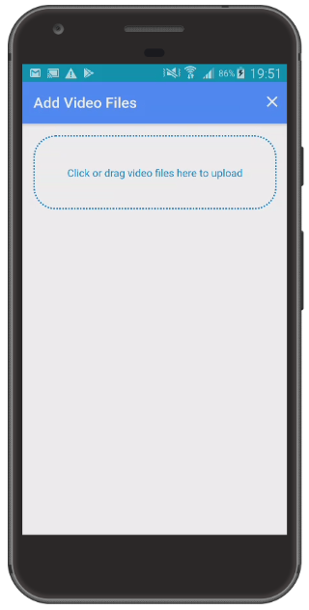

Figure 14

Here you can either drag and drop some files to upload or touch/click to select them. It is phone app and only touch option is available. Touch the drag zone to select some files.

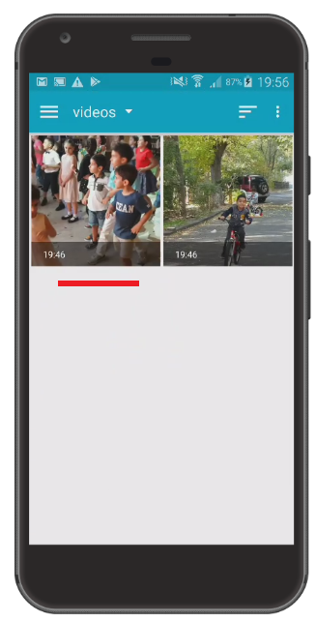

Figure 15

I navigate to my videos folder to pick up some videos. I select left video first.

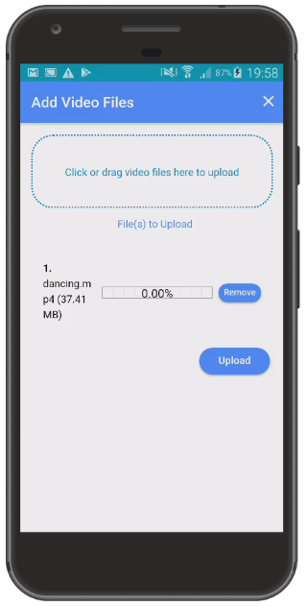

Figure 16

First video was selected. I do the same action to pick up the second one (Figure 15).

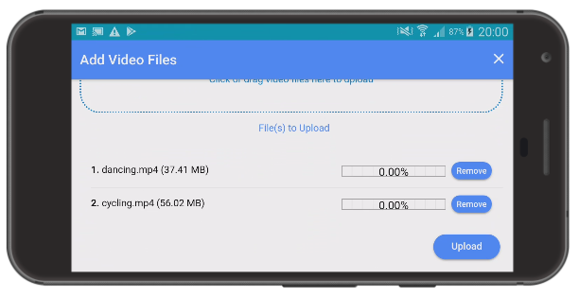

Figure 17

Both videos are selected. Both have mp4 format. First one is 37MB and the second one is 56MB. Touch 'Upload' button.

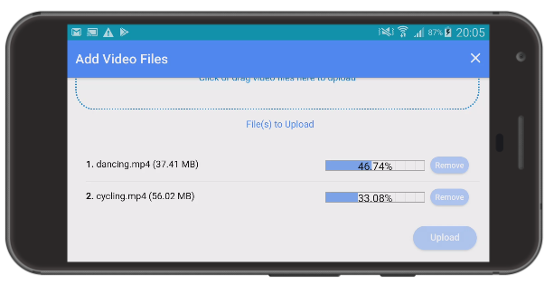

Figure 18

You see the actual upload progress bar indicator and percentage uploaded.

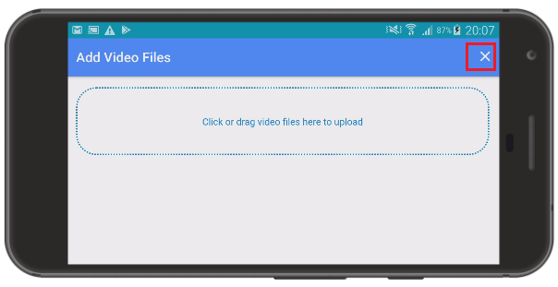

Figure 19

Select other files to upload or just close the window once the files uploaded.

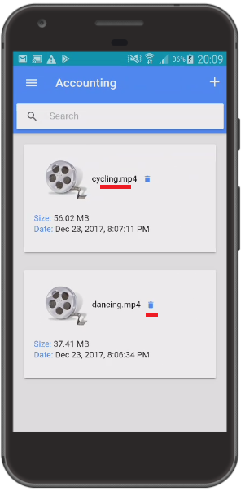

Figure 20

Here are uploaded files for category 'Accounting'.

Uploaded files can be downloaded by clicking an uploaded file name such as 'cycling.mp4'.

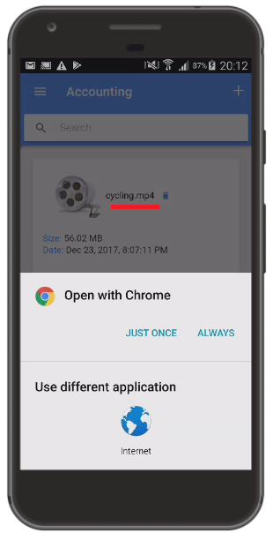

Figure 21

'cycling.mp4' is downloaded and requires app to play.

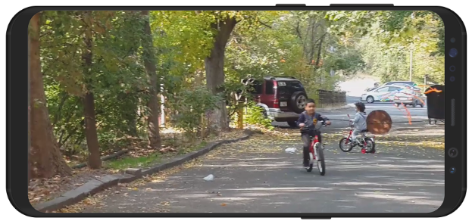

Figure 22

Playing 'cycling.mp4' video on my phone.

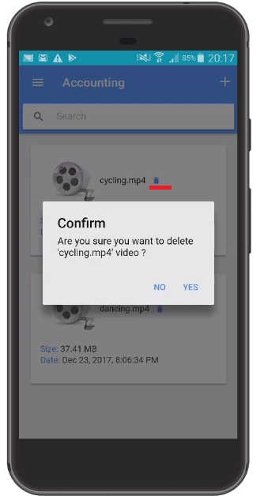

Figure 23

It is also possible to delete videos. Just touch delete icon next to video.

File upload/download is exactly the same process for the phone web app case. (Figure 11).

Let's switch to desktop web app.

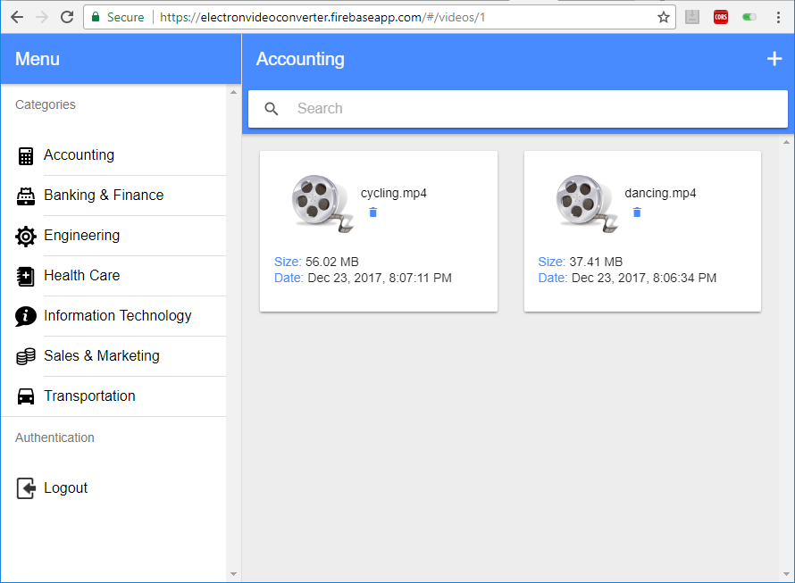

Figure 24

Videos on desktop browser app uploaded via phone.

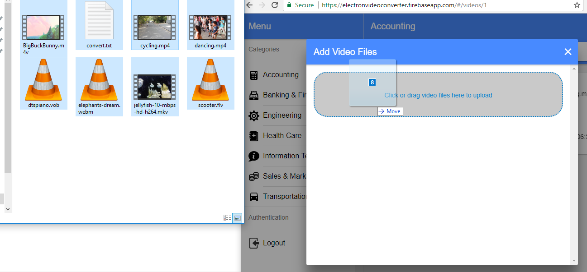

Figure 25

On desktop I can use drag and drop option. I drag eight files to drop zone.

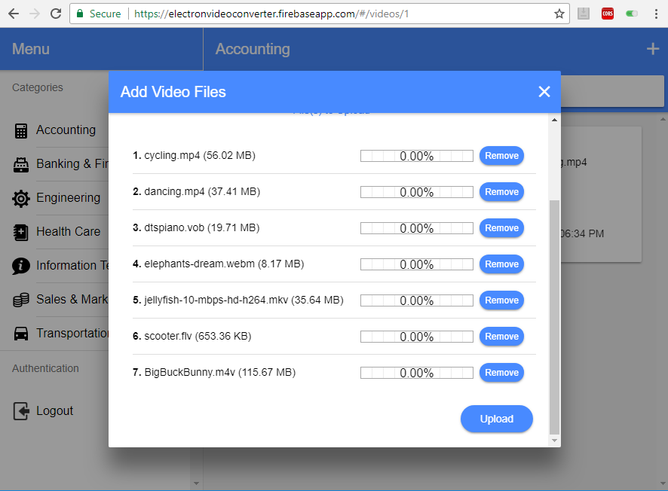

Figure 26

Instead of eight files we have seven on Add Video dialog. The reason is that the app only accepts video files. 'convert.txt' file (Figure 25) is rejected as it is not a video file.

Dropped files have different formats such as mp4, m4v, vob etc. and the shorted file is 'scooter.flv' 653 KB. It is possible to remove some files before uploading.

Click 'Upload' button to start uploading.

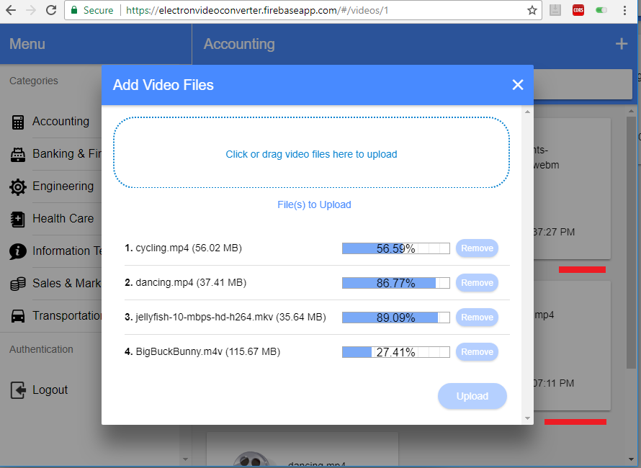

Figure 27

Uploaded files card info is rendered in the background as soon as a file upload is finished as Firebase Realtime Database is used for this app.

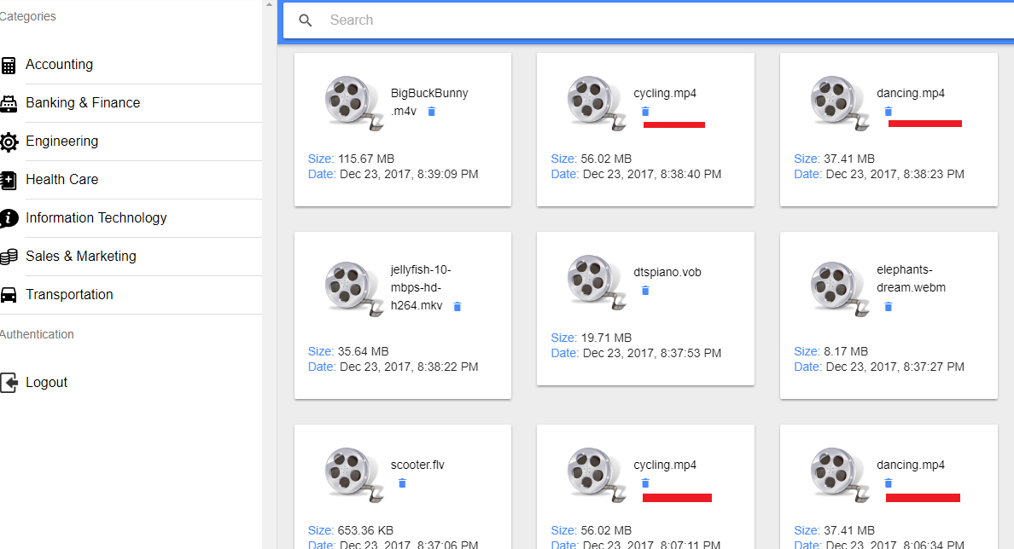

Figure 28

You may notice we have two 'cycling.mp4' and 'dancing.mp4'. They have been uploaded both via phone (Figure 20) and the desktop (Figure 27).

It is valid to have files with the same name and extension in this app. Now it is time to convert videos. That is our Electron app responsibility.

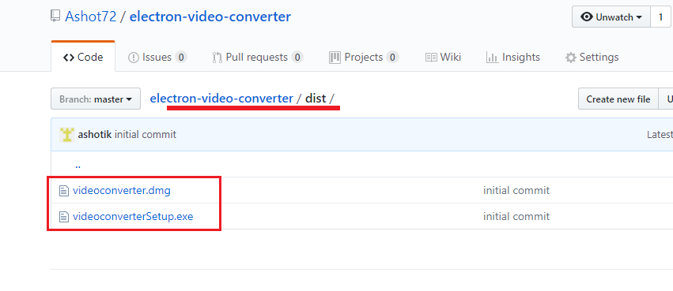

Electron Video Converter GitHub Raspatory <https://github.com/Ashot72/electron-video-converter/tree/master/dist>

'dist' folder includes 'videoconverterSetup.exe' (50MB) and 'videoconverter.dmg' (82MB) files. You can download each of them separately based on your platform.

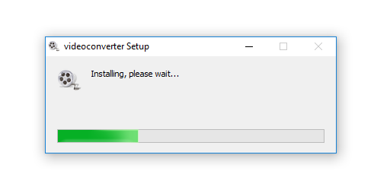

Figure 29

Click 'videoconverter-setup.exe' if your OS is Windows. 'videoconverter-setup.exe' is Windows installer.

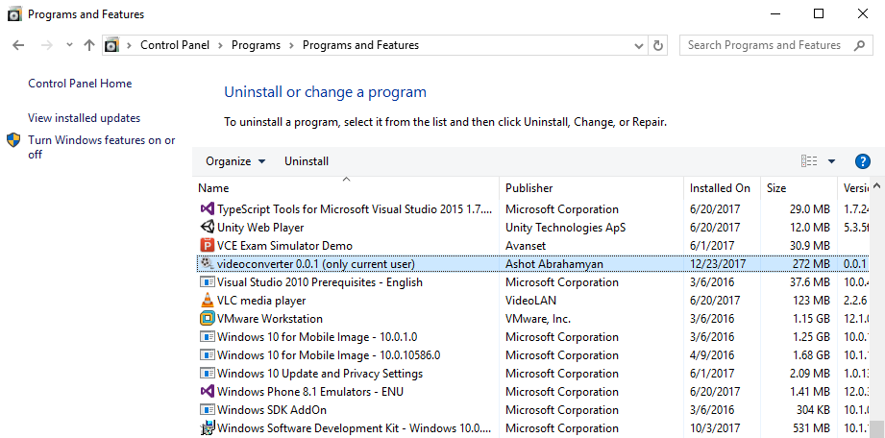

Figure 30

Electron video converter app is installed and can be found under control panel.

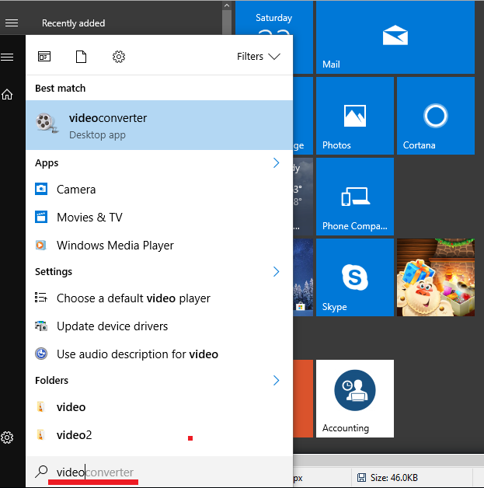

Figure 31

Searching 'videoconverter' to run on Windows.

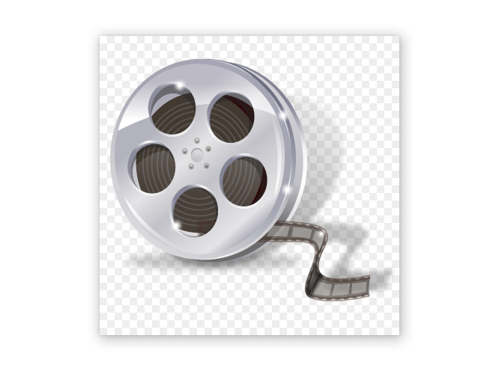

Figure 32

First thing that you will see once the app is starting is splash screen.

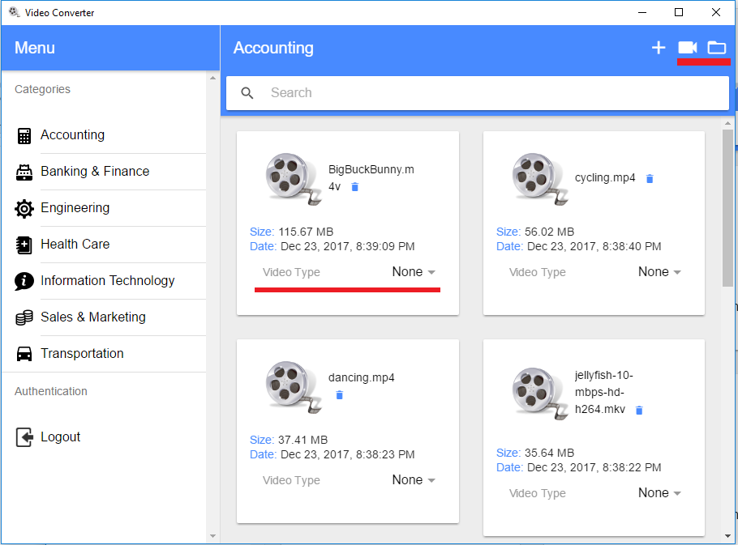

Figure 33

Here is our Electron app. It is a desktop app. The main difference that you will see is 'Video Type' line and two more icons at the top right corner. We will come back to this later.

Now, switching to macOS and do the app installation there.

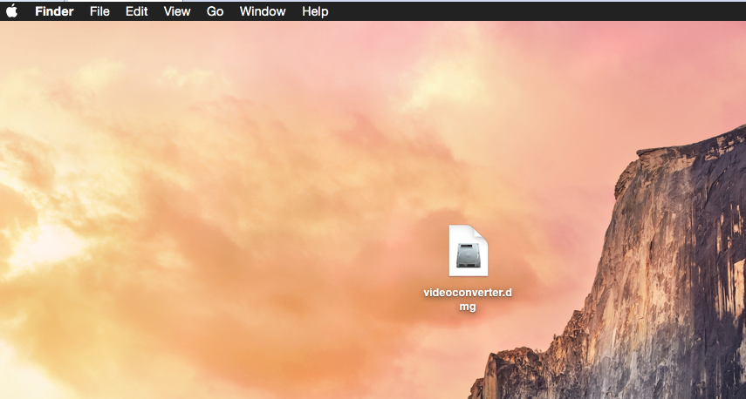

Figure 34

videoconverter.dmg on my macOS. Clicking to run it.

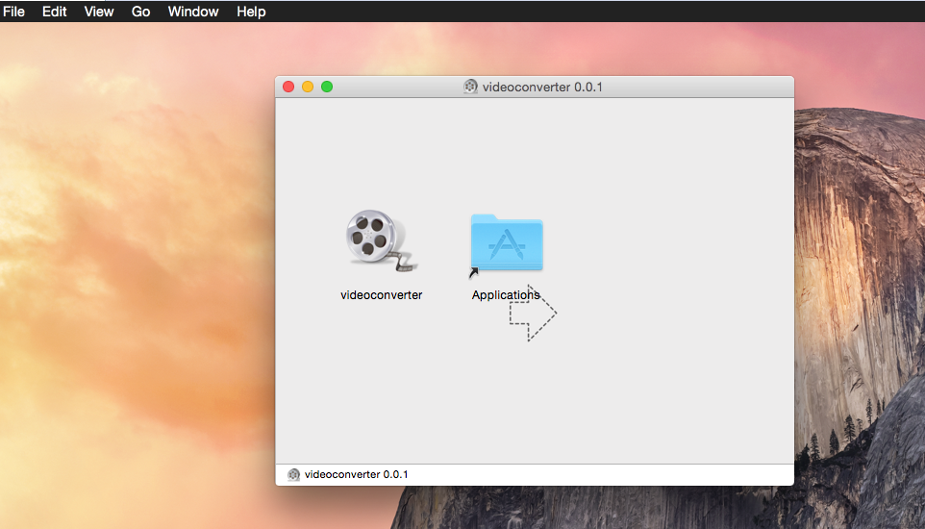

Figure 35

Videoconverter.dmg is linked to 'Applications'. We should drag 'videoconverter.app' to Applications (A) area to install it.

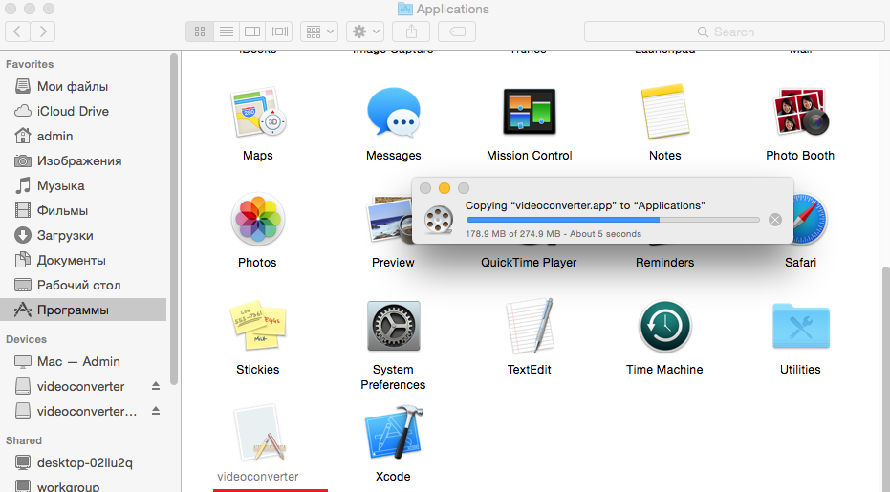

Figure 36

Videoconverter being installed.

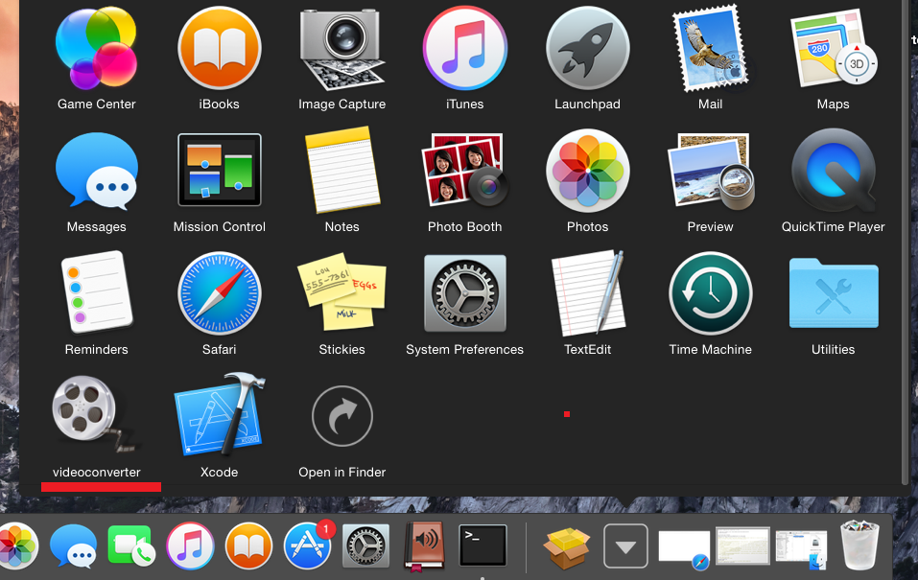

Figure 37

Videoconverter is installed. Click to run it.

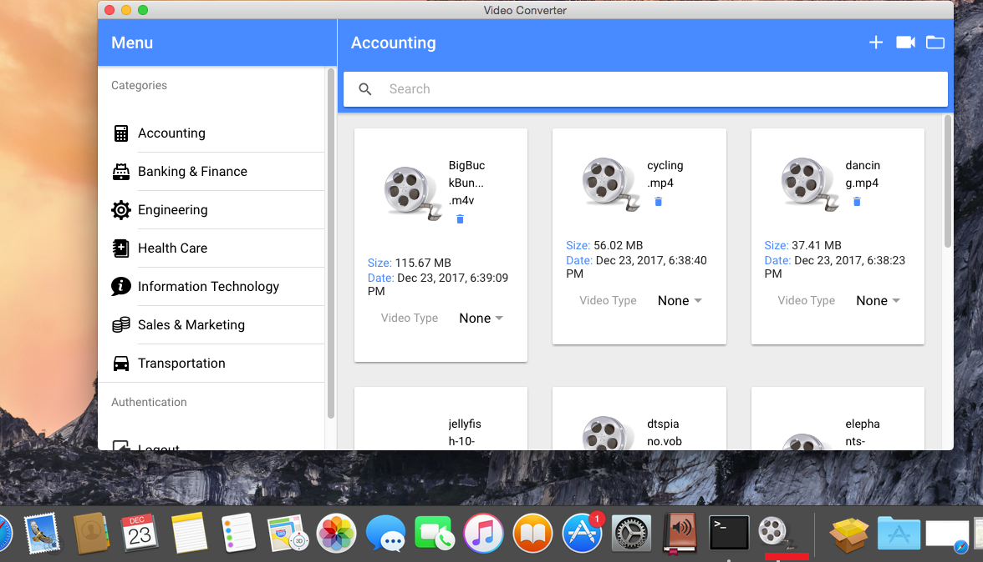

Figure 38

Electron video converter app is running. It can be restarted via video converter dock icon.

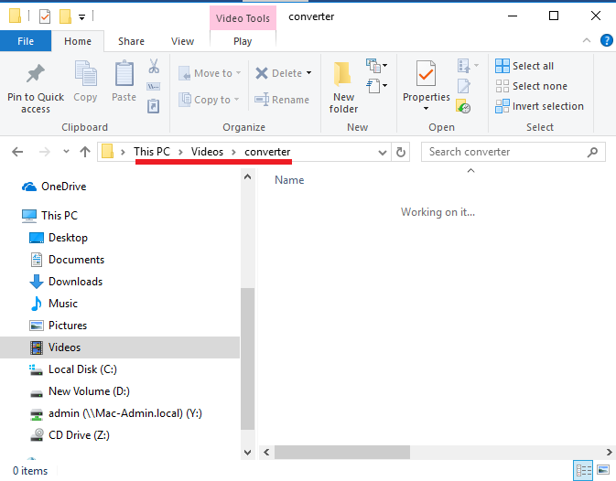

Figure 39

'converter' folder is created under 'Videos' on Windows once our electron application ran for the first time. It is the folder where actual video conversion will take place.

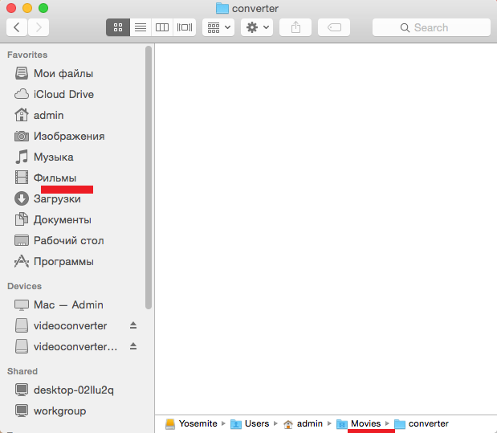

Figure 40

For macOS 'converter' is created under Movies.

It is time to convert some videos and see it in action.

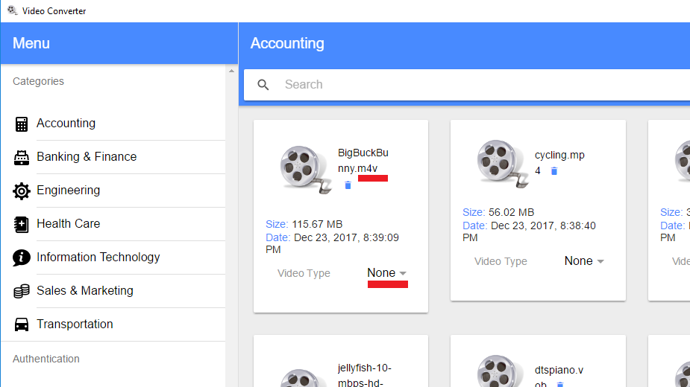

Figure 41

First video is 'BigBuckBunny.m4v'. In order to convert it to another type you should select a Video Type.

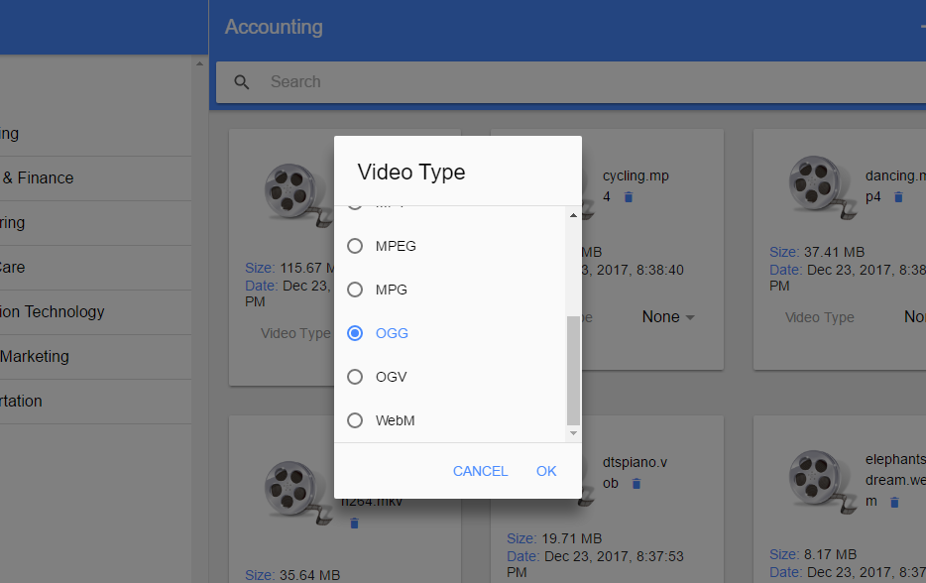

Figure 42

We specified nine video types to be converted; AVI, M4V, MOV, MP4, MPEG, MPG, OGG, OGV and WebM.

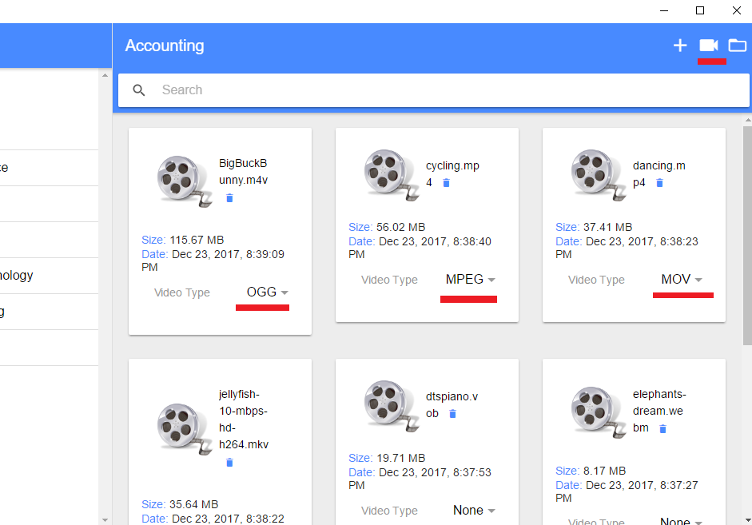

Figure 43

We are going to convert BigBuckBunny.m4v to ogg, cycling.mp4 to mpeg and dancing.mp4 to mov. Click video icon at the top right corner to start video converting.

I am on Windows.

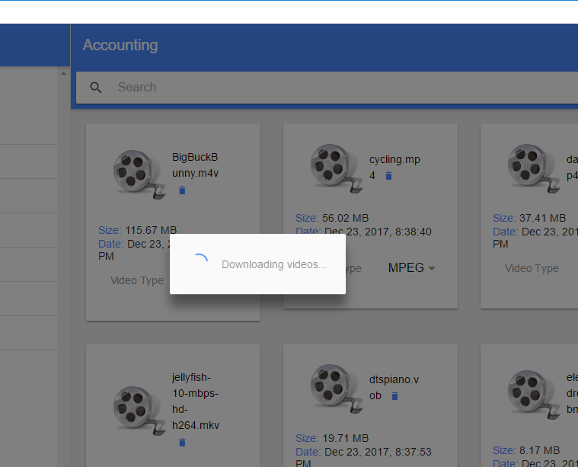

Figure 44

First, selected videos will be downloaded to your hard drive's 'converter' folder (Figure 39).

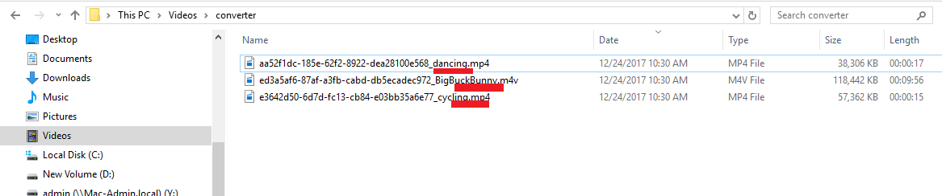

Figure 45

'

Here are three files downloaded from the server.

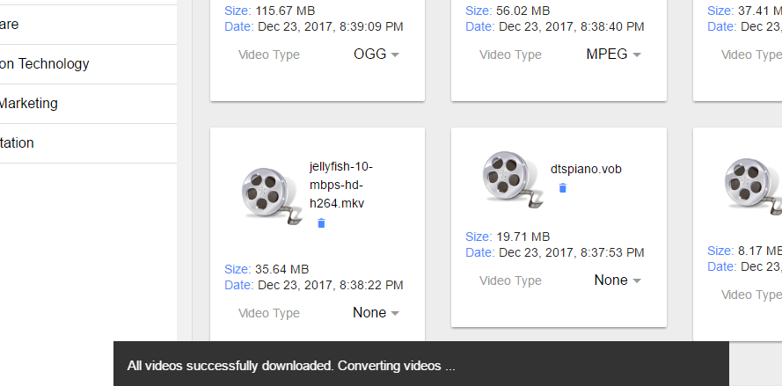

Figure 46

'

Conversion process will start after all files being downloaded.

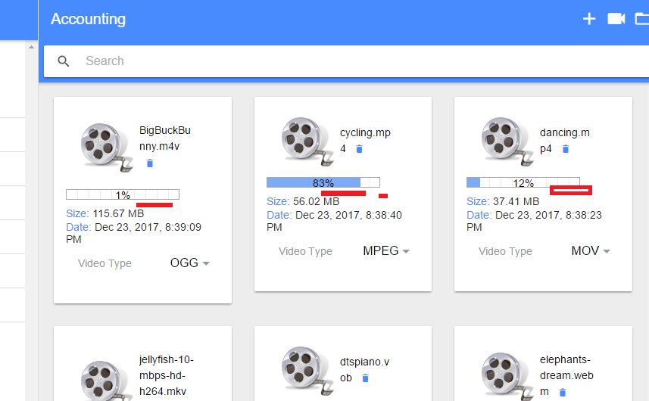

Figure 47

MPEG conversion is very fast though the file size is 56 MB.

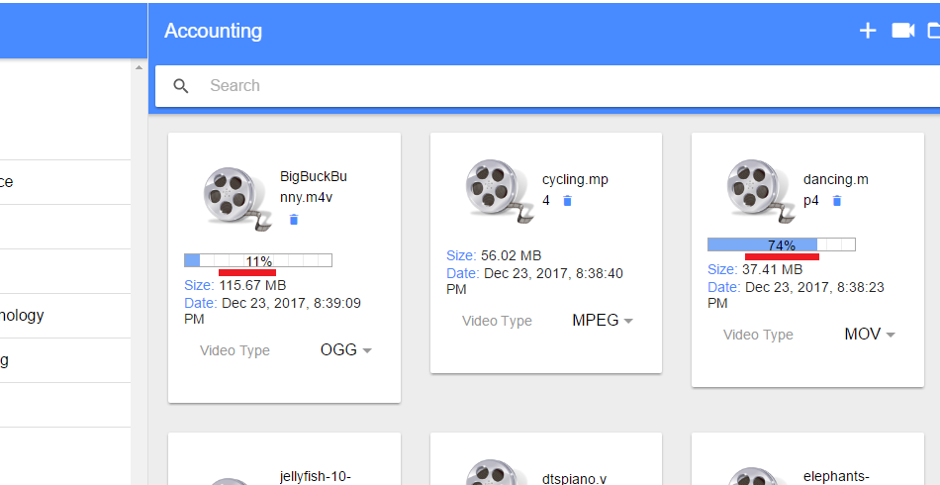

Figure 48

Remaining two videos are still in progress.

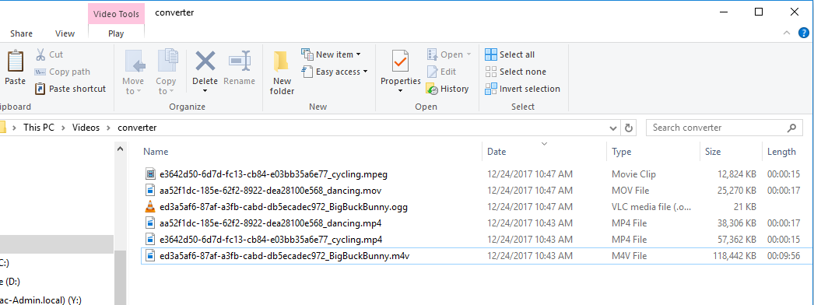

Figure 49

'converter' folder will be opened automatically and you can see the converted files once all conversions are finished.

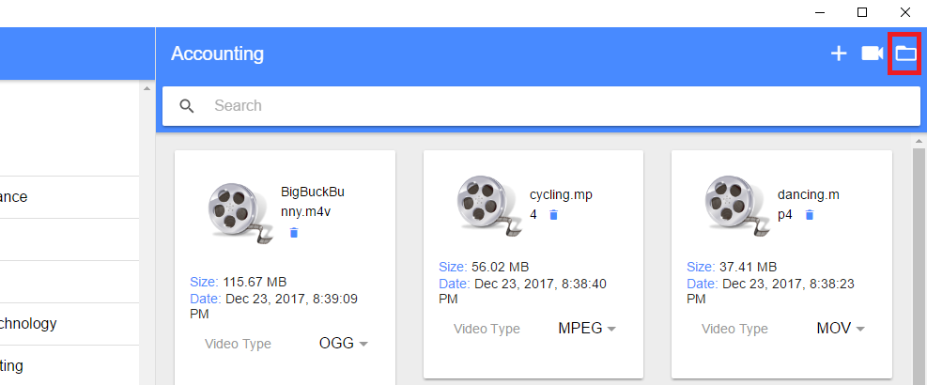

Figure 50

You can open converter folder right from the app any time by clicking the folder icon. No need to go to Windows Explorer or macOS Finder to open it.

Let's run converted videos.



Figure 51

'

This is converted BigBuckBunny.ogg file.

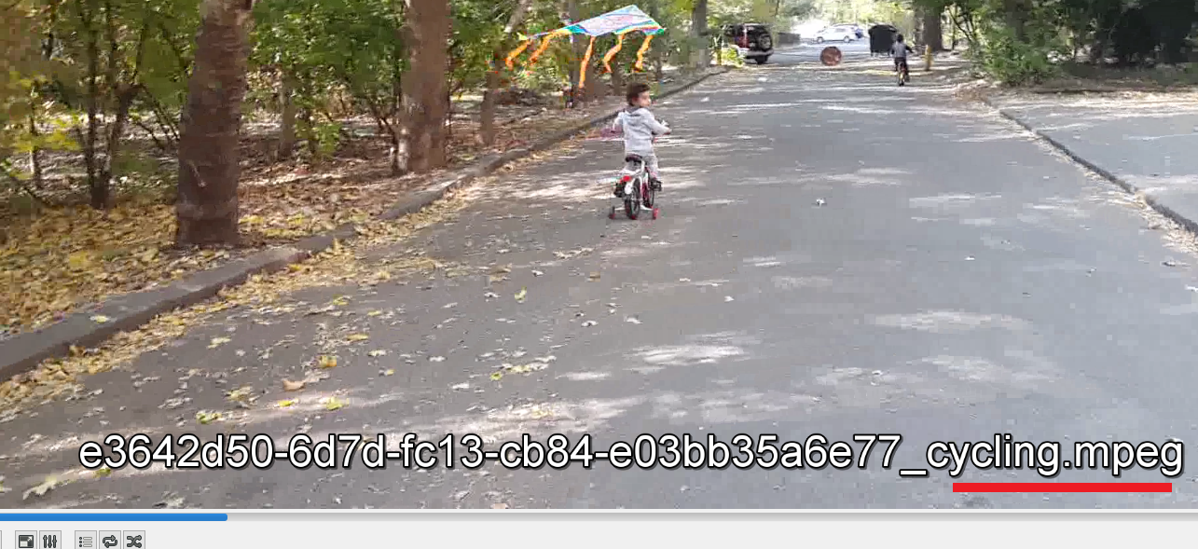

Figure 52

'

Here is converted cycling.mpeg.



Figure 53

Converted dancing.mov video.

Trying video conversion on macOS.

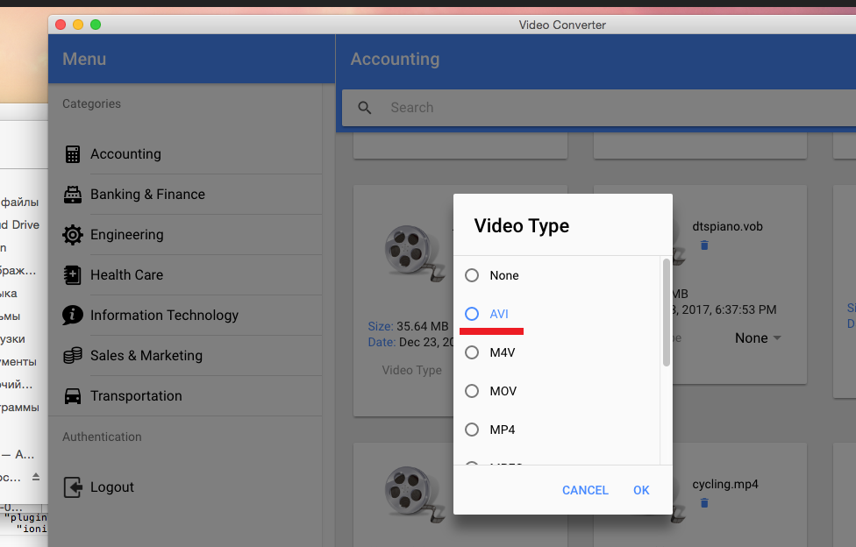

Figure54

We user Ionic Framework in this application and seems Mac has an issue with 'ion-select' control. 'ion-select' is the control to select a video type.

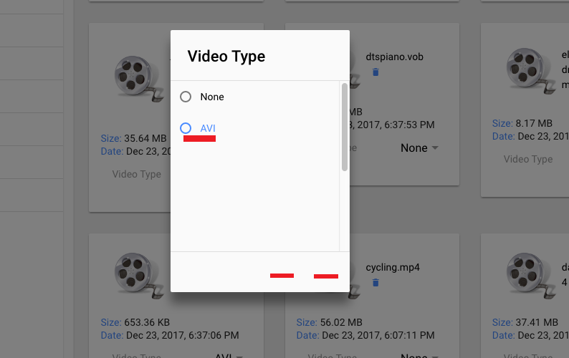

Figure 55

All options are cellared out along with Cancel and OK buttons as soon as we pick up a type to convert. I selected 'AVI' option and nothing is rendered below that option.

You can still guess where the OK option is and click it (hand cursor).

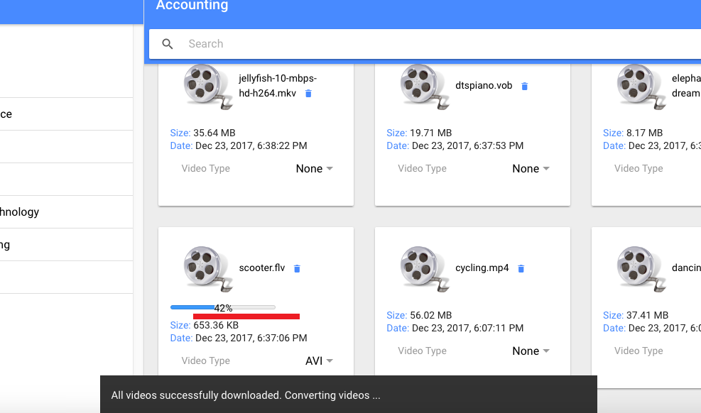

Figure 56

Type is selected and we can go on with the conversion. Scooter.flv is converting to avi.

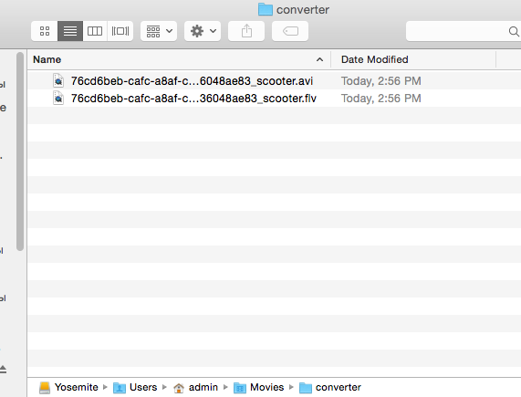

Figure 57

'

flv video has been converted to avi.

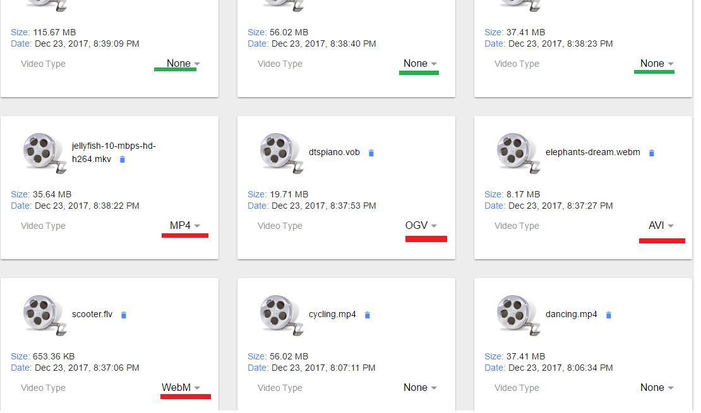

Figure 58

One more conversion. First, we set pervious conversions to 'None' not to convert them again. We are going to convert jellyfish-10-mbps-hd-h264.mkv to mp4, dtspiano.vob to ogv,

Elephants-dream.webm to avi, scooter.flv to webm. Note, all files in 'converter' folder will be deleted as soon as a new video conversion is starting.

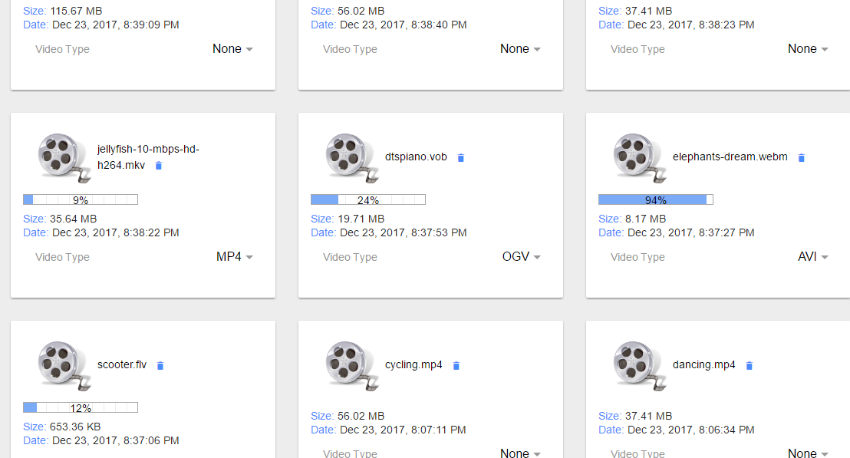

Figure 59

Video conversion started.

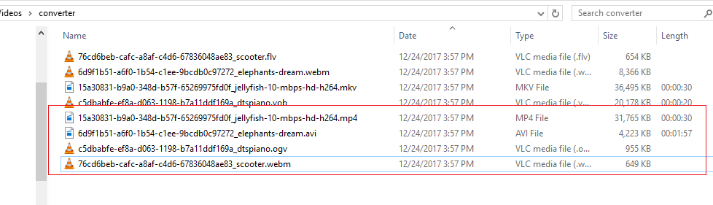

Figure 60

Here are converted files.

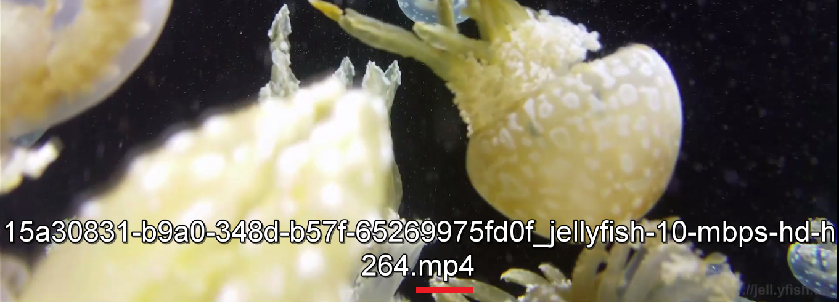

Figure 61

Converted jellyfish-10-mbps-hd-h264.mp4

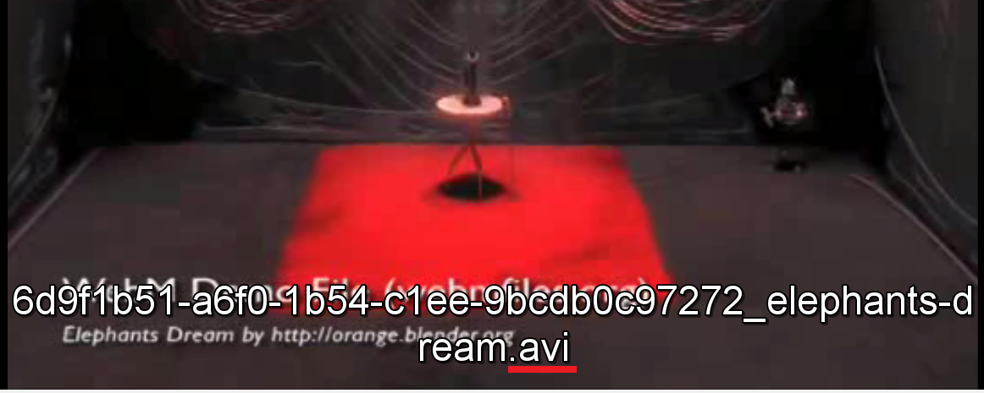

Figure 62

Converted Elephants-dream.avi

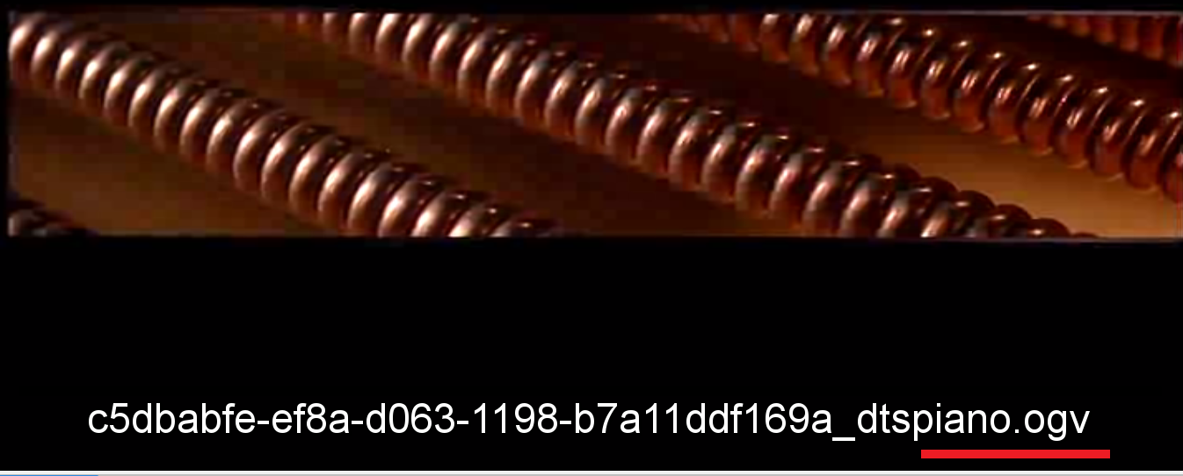

Figure 63

Converted dtspiano.ogv

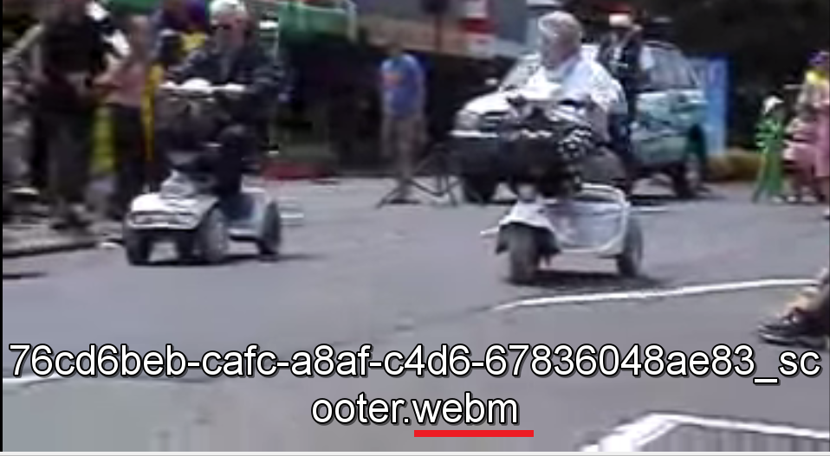

Figure 64

Now, you can upload the converted files to server as other users may have video players to run only converted type of videos.

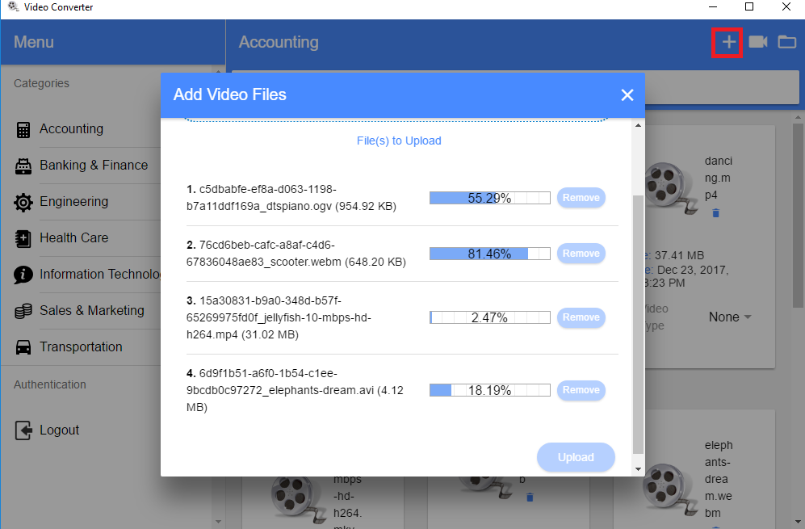

Figure 65

This time uploading files via electron app instead of browser.

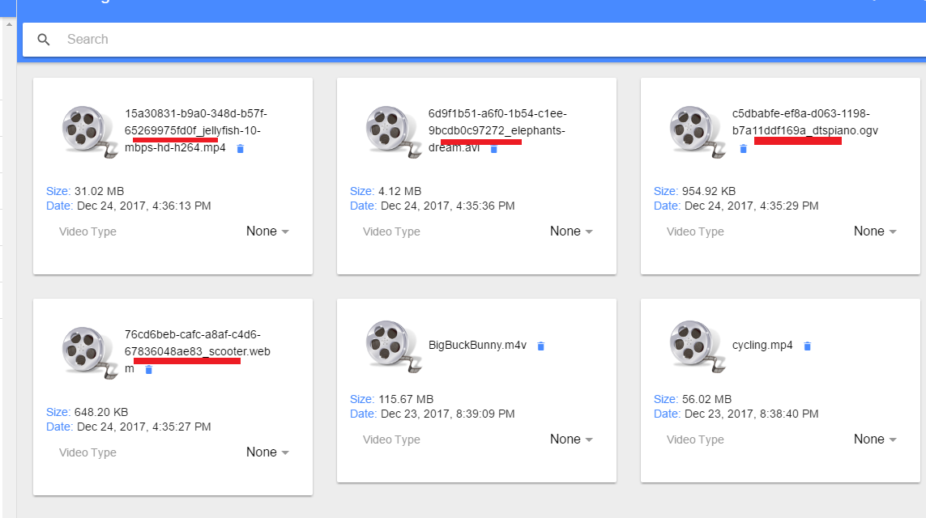

Figure 66

Converted files uploaded to server. We could have removed GUID prefix before uploading them.

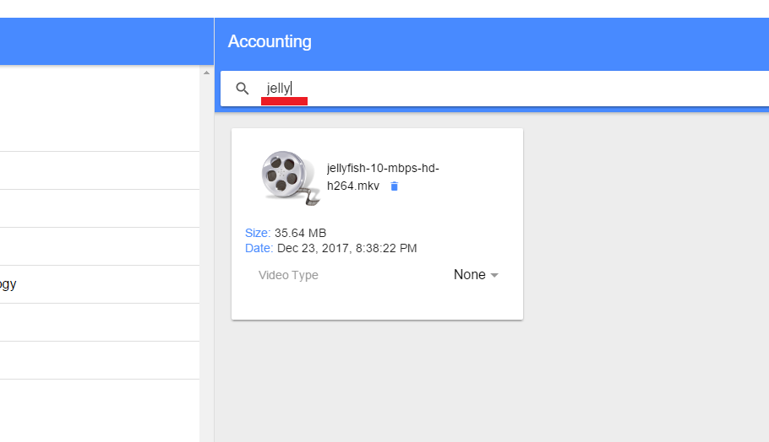

Figure 67

You can search videos by video name.